**Exercise 1**

**1. Write a program that computes the perimeter and the area of a rectangle. Define**

**your own values for the length and width. (Assuming that L and W are the length**

**and width of the rectangle, Perimeter = 2*(L+W) and Area = L*W.**

**Ans:**delimiter //

mysql> create procedure RectangleCalculations(length int,width int)

-> begin

-> declare perimeter int;

-> declare area int;

-> set perimeter=2*(length+width);

-> set area = length*width;

-> select perimeter as Perimeter, area AS Area;

-> end//  
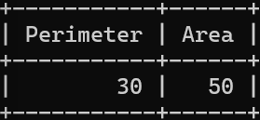

**2. Write a program that declares an integer variable called num, assigns a value to it,**

**and computes and inserts into the tempp table the value of the variable itself, its**

**square, and its cube.**

**Ans:   
mysql> DELIMITER //**

**mysql> CREATE PROCEDURE**

**-> InsertNumDetails(num INT)**

**-> BEGIN**

**-> DECLARE square INT;**

**-> DECLARE `cube` INT;**

**-> SET square = POWER(num, 2);**

**-> SET `cube` = POWER(num, 3);**

**-> INSERT INTO tempp (num, square, `cube`)**

**-> VALUES (num, square, `cube`);**

**-> END//**

**Query OK, 0 rows affected (0.02 sec)**

**call InsertNumDetails(10,20);  
CREATE TABLE tempp (**

**-> num INT,**

**-> square INT,**

**-> `cube` INT**

**-> );  
select * from tempp;  
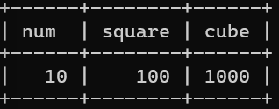**

**3. Convert a temperature in Fahrenheit (F) to its equivalent in Celsius (C) and vice**

**versa. The required formulae are:- C= (F-32)*5/9**

**F= 9/5*C + 32**

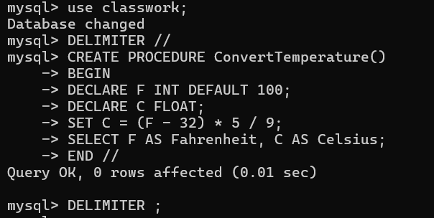

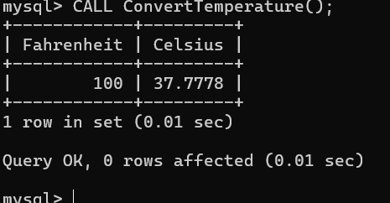

**Ans:**

**4. Convert a number of inches into yards, feet, and inches. For example, 124 inches**

**equals 3 yards, 1 foot, and 4 inches.**

**Ans:** 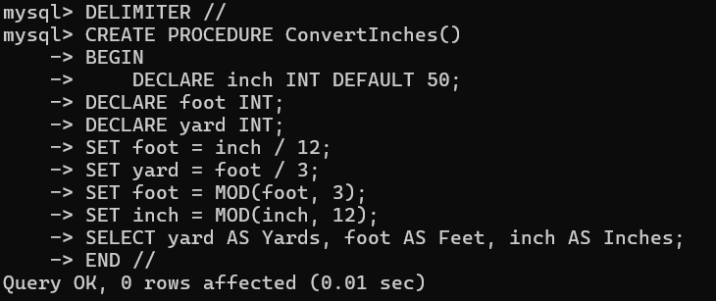

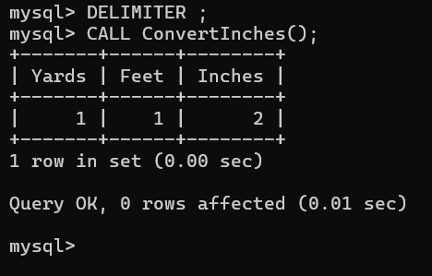

**5. Write a program that enables a user to input an integer. The program should then**

**state whether the integer is evenly divisible by 5.**

**Ans:** 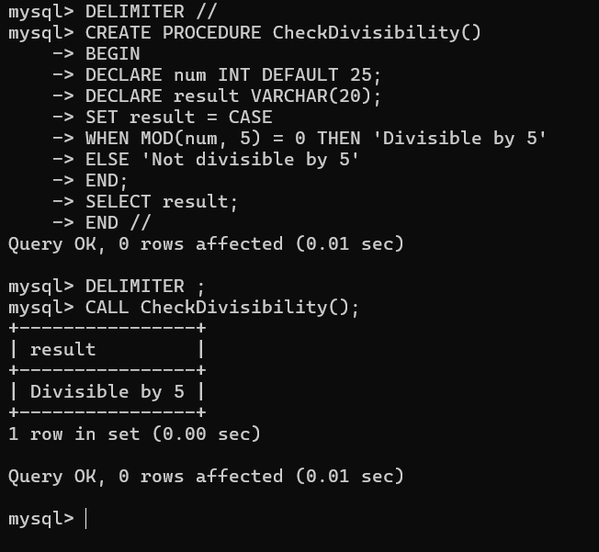

**6. Your block should read in two real numbers and tell whether the product of the two**

**numbers is equal to or greater than 100.**

**Ans:**

